Question 21:

Two matrices are said to be equal if they have the same dimension and their corresponding elements are equal.

For example, the two matrices A and B is given below are equal:

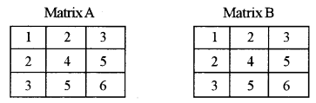

Design a class **EqMat** to check if two matrices are equal or not. Assume that the two matrices have the same dimension.

Some of the members of the class are given below :

Class name: **EqMat**

**Data members/instance variables:**  
**a[][]** : to store integer elements  
**m:** to store the number of rows  
**n:** to store the number of columns

**Member functions/methods:**  
**EqMat(int mm, int nn):** parameterized constructor to initialise the data members m = mm and n = nn  
**void readArray():** to enter elements in the array  
**int check(EqMat P, EqMat Q):** checks if the parameterized objects P and Q are equal and returns 1 if true, otherwise returns 0  
**void print():** displays the array elements

Define the class **EqMat** giving details of the constructor **EqMat(int mm, int nn)**, **void readArray( )**, **int check(EqMat, EqMat)** and **void print( )**. Define the **main( )** function to create objects and call the functions accordingly to enable the task.